Bahria University,

Karachi Campus



COURSE: CEL-439 EMBEDDED SYSTEMS

TERM: FALL 2022, CLASS: BSE- 5(A)

Submitted By:

Abdul Quddos (02-131202-033)

(Name) (Reg. No.)

Submitted To:

**Engr. Syed Zia Uddin/Engr. Rizwan Fazal**

Signed Remarks: Score:

INDEX

|  |  |  |  |  |
| --- | --- | --- | --- | --- |
| SNO | DATE | LAB NO | LAB OBJECTIVE | SIGN |
| 1 |  | 1 |  |  |
| 2 |  | 2 |  |  |
| 3 |  | 3 |  |  |
| 4 |  | 4 |  |  |
| 5 |  | 5 |  |  |
| 6 |  | 6 |  |  |
| 7 |  | 7 |  |  |
| 8 |  | 8 |  |  |
| 9 |  | 9 |  |  |
| 10 |  | 10 |  |  |
| 11 |  | 11 |  |  |
| 12 |  | 12 |  |  |
| 13 |  | 13 |  |  |
| 14 |  | 14 |  |  |

Bahria University,

Karachi Campus



LAB EXPERIMENT NO.

1

LIST OF TASKS

|  |  |
| --- | --- |
| TASK NO | OBJECTIVE |
| **1** | Write a sketch to interface Arduino with LED, LED should blink with a delay of 1 second. |
| 2 | Write a sketch to interface Arduino with SPDT switch & LED. |

Submitted On:

13/10/2022

(Date: DD/MM/YY)

**Task No. 1: Write a sketch to interface Arduino with LED, LED should blink with a delay of 1 second.**

**Solution:**

int LED = 7;

void setup( )

{

pinMode(LED, OUTPUT);

}

void loop( )

{

digitalWrite(LED, HIGH);

delay(1000);

digitalWrite(LED, LOW);

delay(1000);

}

**Output:**

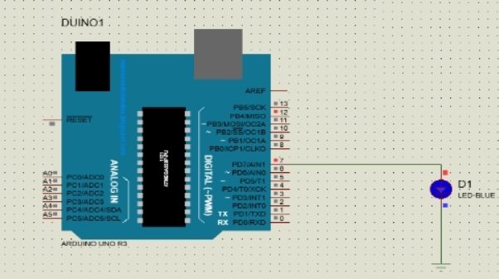

**Task No. 2:** **Write a sketch to interface Arduino with SPDT switch & LED.**

**Solution:**

void setup() {

pinMode(12,INPUT);

pinMode(7,OUTPUT);

}

void loop() {

int sw = digitalRead(12);

if(sw==1)

{

digitalWrite(7,HIGH);

}

else

digitalWrite(7,LOW);

}

**Output:**

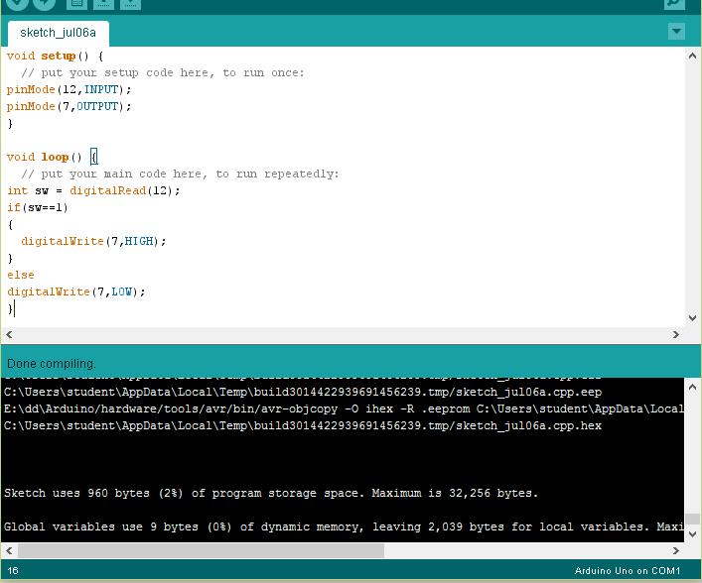

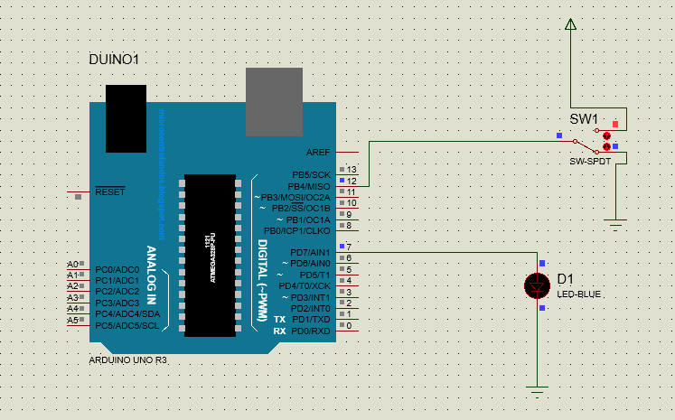

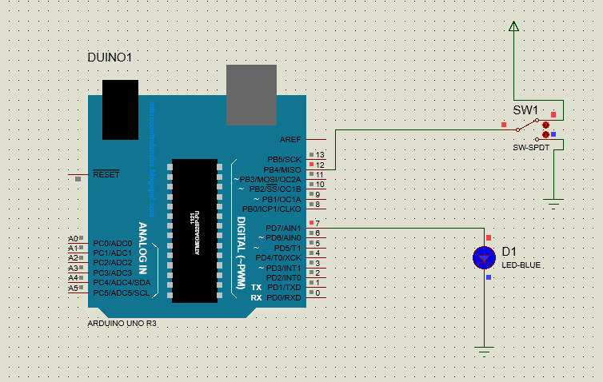

Bahria University,

Karachi Campus



LAB EXPERIMENT NO.

2

LIST OF TASKS

|  |  |
| --- | --- |
| TASK NO | OBJECTIVE |
| 1 | Write a sketch to interface Arduino with the Relay. The Relay should be controlled by a SPDT Switch. |

Submitted On:

13/10/2022

(Date: DD/MM/YY)

**Task No. 1: Write a sketch to interface Arduino with the Relay. The Relay should be controlled by a SPDT Switch.**

**Solution:**

void setup(){

pinMode(12,INPUT);

pinMode(7,OUTPUT);

}

void loop() {

int sw=digitalRead(12);

If(sw==1)

{ digitalWrite(7,HIGH); }

else

digitalWrite(7,LOW);

}

void setup() {

pinMode(12,INPUT);

pinMode(7,OUTPUT);

}

void loop() {

int sw = digitalRead(12);

if(sw==1)

{

digitalWrite(7,HIGH);

}

else

digitalWrite(7,LOW);

}

**Output:**

